Tentative Sixth Grade Supply List

Language Arts:

EITHER: (1) 5-Subject College Ruled (NO WIDE-RULED!!) OR

(2) 1-Subject College Ruled Notebooks (100+ pages each)

Notebooks MUST be a minimum of 8 ½” x 11” in size!

Glue (liquid or stick)

Highlighters: blue/green/yellow/pink/orange

History and Math: These two subjects will share a three-ring binder The binder needs to be 2 inches, and a pack of 5 tab dividers, loose-leaf paper

Reading: 2 - Three-pronged folders, loose-leaf paper

Science: 3-subject notebook College-Ruled ONLY (8 ½” x 11”)

Liquid Glue (2) and Stick Glue (2)

ALL SUBJECTS NEED THE FOLLOWING MATERIALS (THESE CAN BE SHARED AMONG ALL CLASSES):

PENCILS

PENCIL SHARPENERS – WE DON’T HAVE ELECTRIC SHARPENERS

CRAYONS/COLORED PENCILS

GLUE

HIGHLIGHTERS

PENS

LOOSE LEAF PAPER

Any questions: please contact Karen.burchfield@hcps.net

Science: 3-subject Notebook Math/History

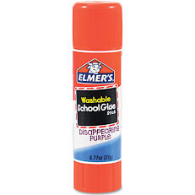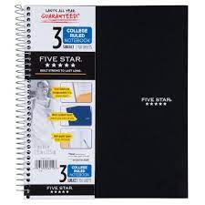(Must be College-Ruled 8 ½” x 11”) 2- inch Binder + 5 tab dividers

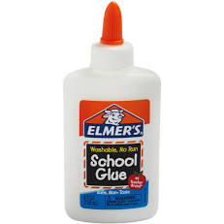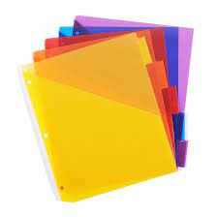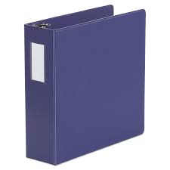

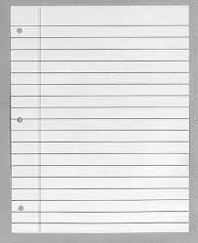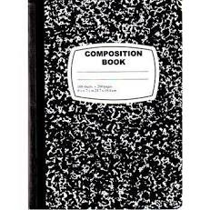Composition Loose-Leaf

Notebook Paper

Language Arts: Notebook: MUST BY COLLEGED-RULED and 8/12” x 11”

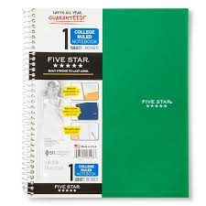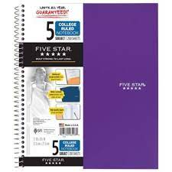Either (2) One-Subject OR (1) 5-Subject Glue (liquid or stick)

OR

Reading: Shared Materials:

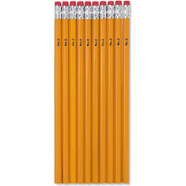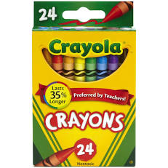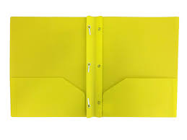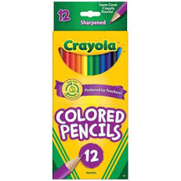(2) Three-pronged folders

Loose-Leaf

Paper

